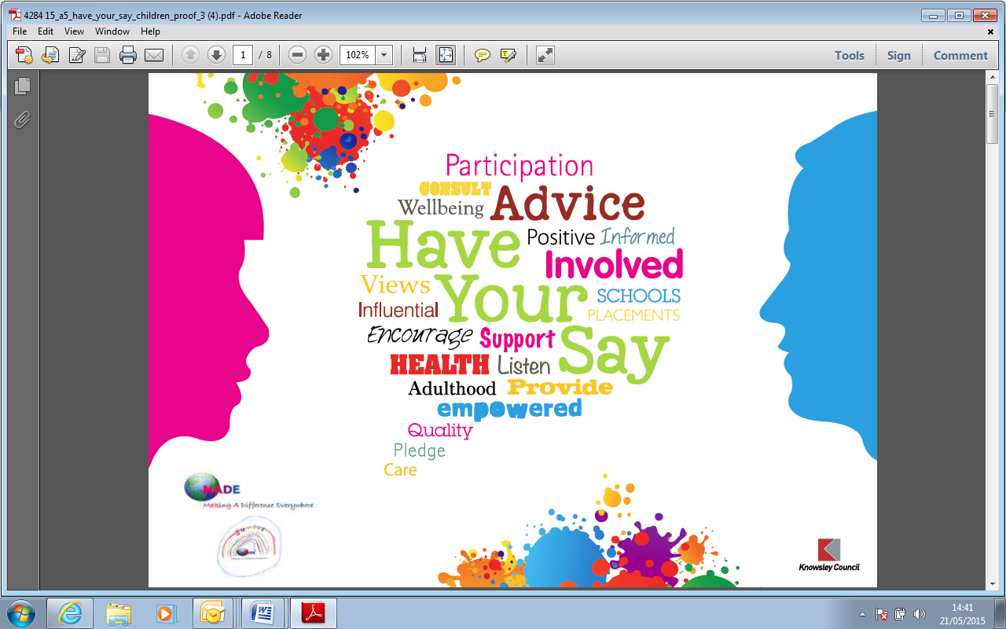

We have young people as your panel of ‘Britain’s got talent’ style judges.

**We are holding auditions for performers on 20th July in Our place, Longview drive Huyton at 4.30pm – 6pm**

**Contact Sam McIver on 0151-443-4021 or email** [**Samantha.mciver@knowsley.gov.uk**](mailto:Samantha.mciver@knowsley.gov.uk) **to confirm your audition time slot.**

Can you sing or dance? Do you have your own band? Or are you a budding comedian?

Do you want to perform at Knowsley Children looked after and care leavers Celebration of Achievement event? Then come and audition for a chance to perform on the night!

**ARE YOU INTERESTED ????**

You HAVE got talent!!!